Instructions for assembling optical cable:

Disassemble connector with marked optical wire.

1) pull of the metal clamp as shown on the picture:
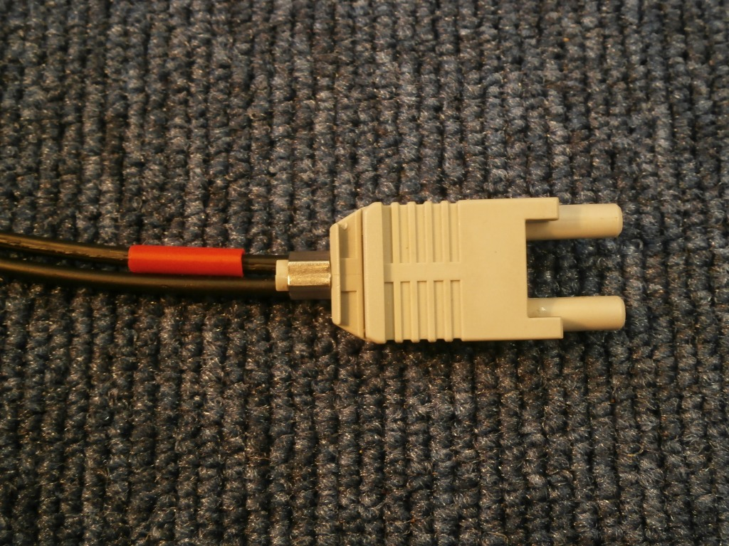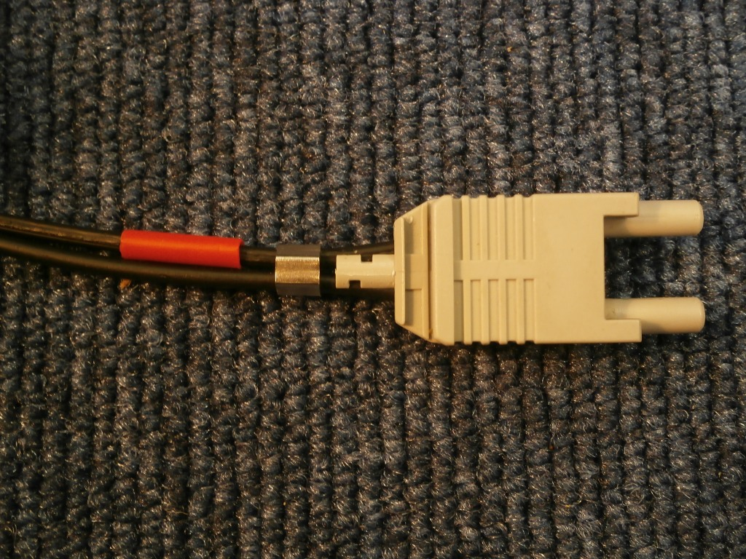

2) Remove the gray plastic connector from the cable
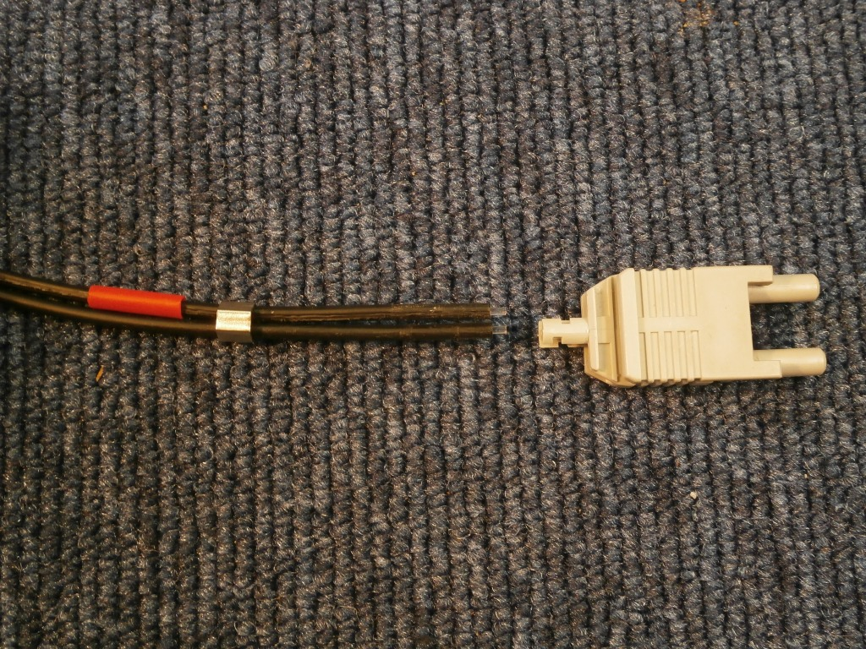

At this moment you can put cable to the machine.

3) Insert wires into gray plastic connector

4) Check optical wires are fully inserted in connector

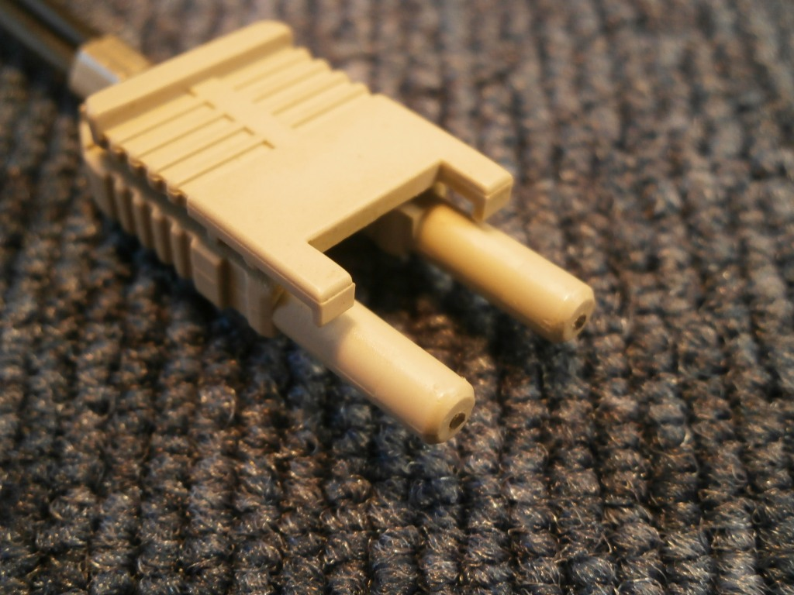
Optical wire

5) Pull on the metal clamp

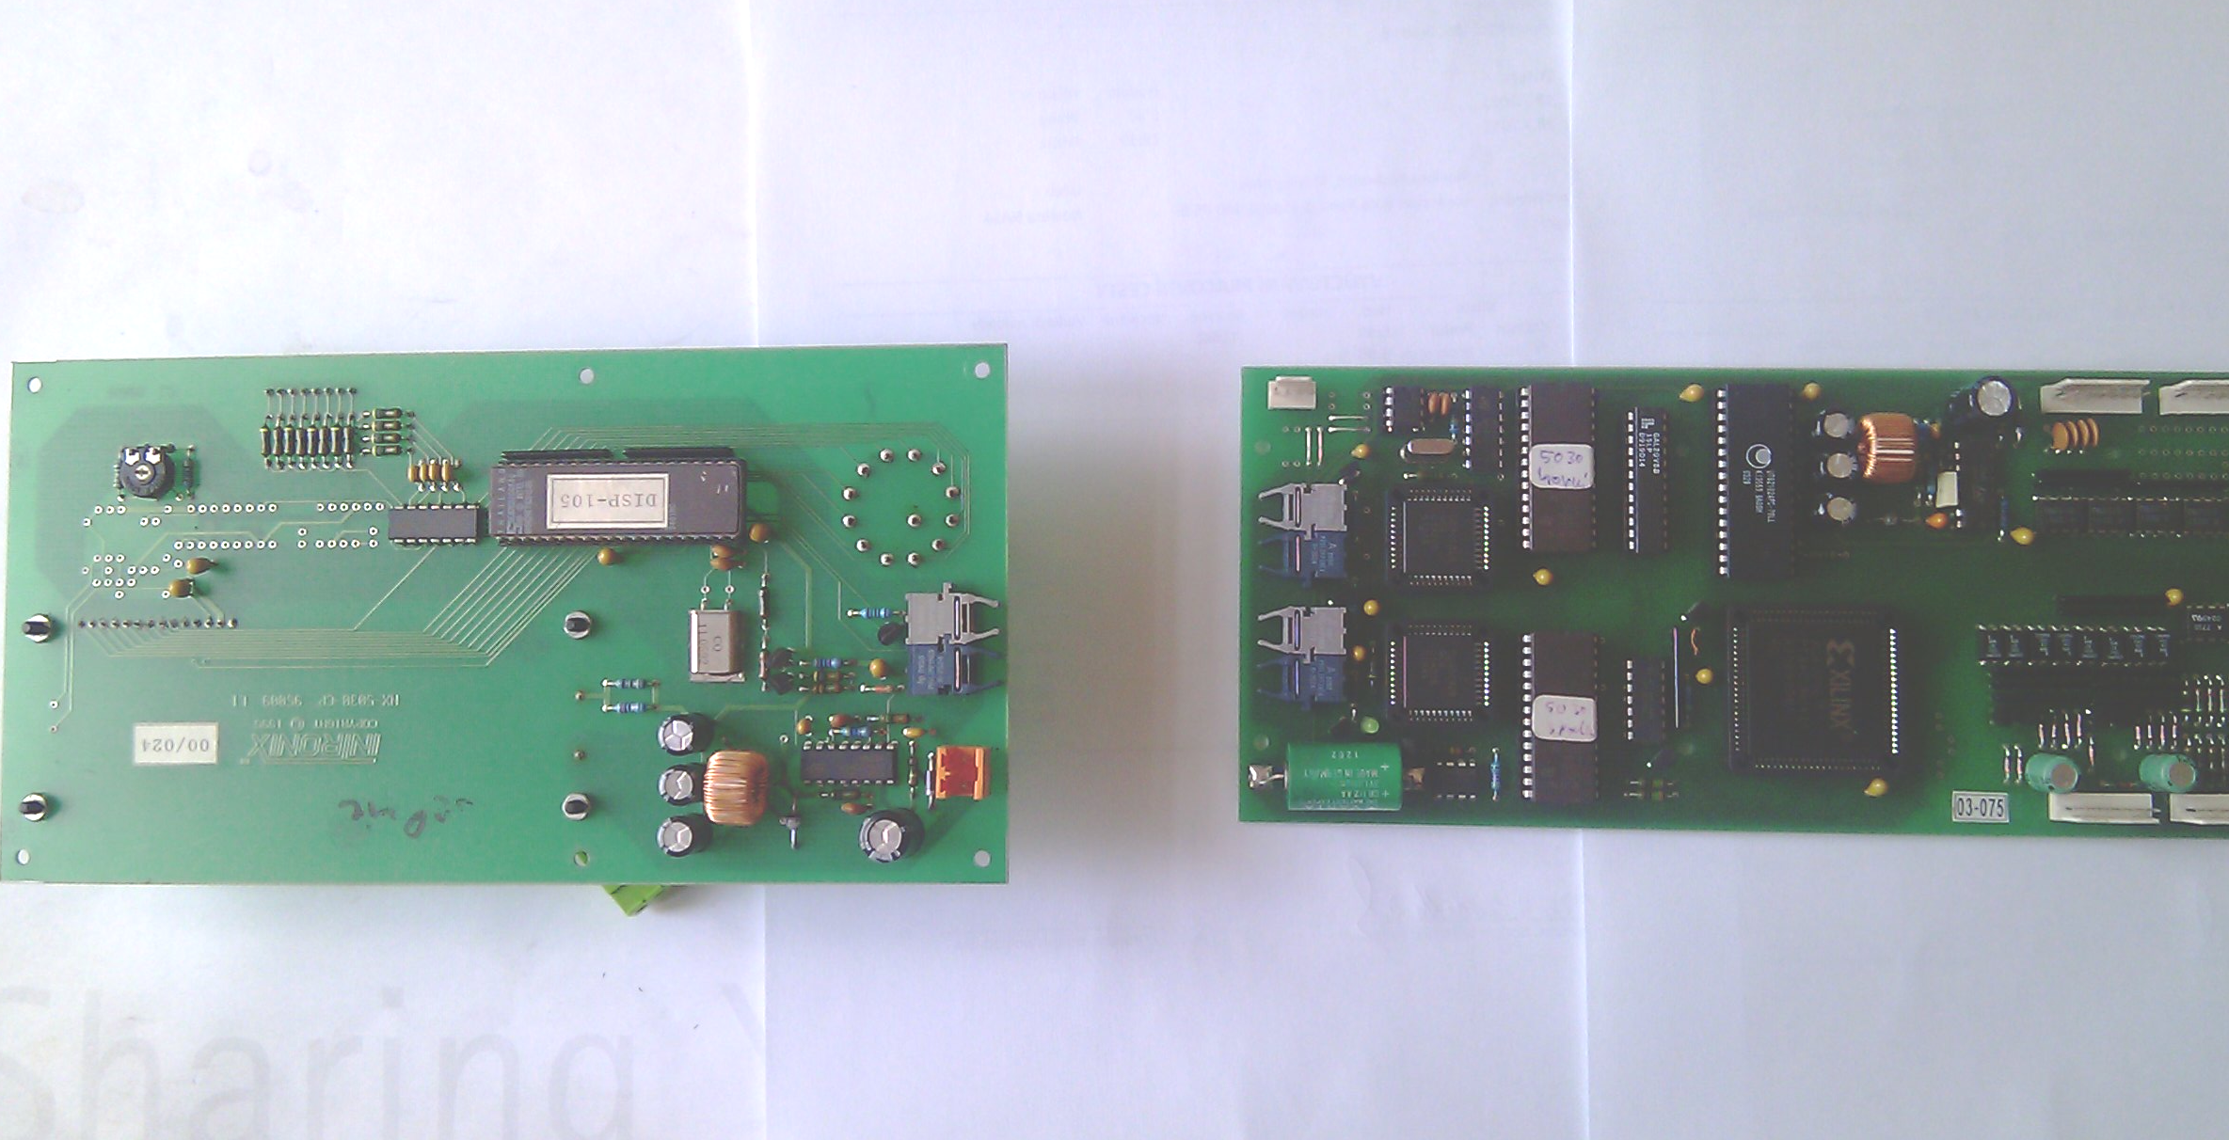
Transmitter
Receiver
Transmitter
Receiver
Connection between transmitter and receiver

Troubleshooting:

Optical wire always connects transmitter on one side and receiver on other side.

Optical cable on one side is marked by red sign. Marked optical wire plug in to display’s reciever.
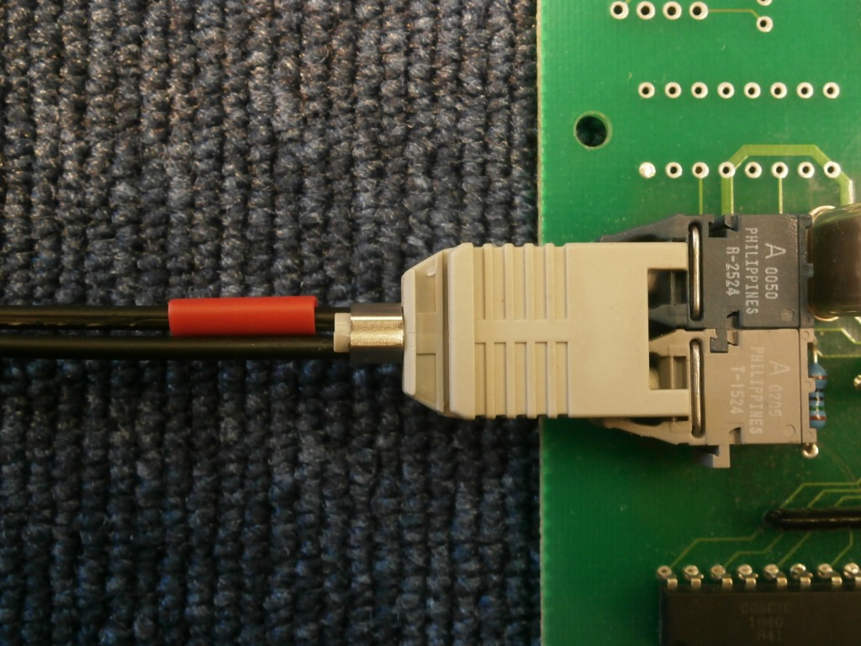

Transmitter and receiver are placed identically on newer and older system, do not rotate optical cable and connect it in the same way to new system.

Transmitter has light gray color.
Receiver has dark gray.

When the control system is turned on and transmitter transmits, it emits visible red laser, so it could be checked on the other side of cable which one is from transmitter and which from receiver.

